REPORT

Problem Analysis And Research

In post disaster situations like earthquake, floods and hurricanes people can’t stay in their houses, it requires them to stay in disaster relief shelters to obtain protection, safety, comfort, and security . In the first phase, people will stay in an emergency shelter. In providing this facility don’t need to construct a temporary building because it only refers to the aftermath of the disaster. Therefore, they will use existing building space like a public or social facility. Due to the limitation of this facility, such as space and privacy, people will be moved to the temporary shelter. This facility is designed to suit family or group size, so it can provide privacy and more space to carry out simple activities and ensure them to rest in good condition for recover their emotional and psychological state .

An emergency situation requires the facilities must be available as soon as possible. In this context, flexible architecture can be an instant solution to answer that problem is because the characters of flexible architecture are dynamic rather than stagnant. They are possible for moving and transforming to be used in different functions .In order to achieve it, the building must be applied portable structure because the building will be lighter and also able to through assembling and also mechanisms systems of the components, so it allows the building to be stowed and moved by vehicles and time-efficient for erecting process in different locations.

Temporary Shelter with Portable Structure

Temporary shelter is an instant facility for sheltering that prioritizing speed and costs efficiency in construction and also have a limited lifetime .The refugees stay in this facility only for a short time, just a few weeks after the disaster [4]. Although speed is the most important aspect, we must consider the human aspect. Temporary shelter is more than just a facility. It is a process for helping rehabilitation, both psychological and mental [3].

Portable structures are designed with prioritizing mobility and efficient aspects. It allows the building to move easily and is also time-efficient in the erection process to a different location. It will be a good solution functionally, structurally, and spatially in an emergency situation. Flexible Architecture with portable structure classified according to the configuration of products and erection process. There are ready-made units, demountable, and deployable shelters .

PROPOSED SOLUTION

“DUAL CAP STRUCTURE”

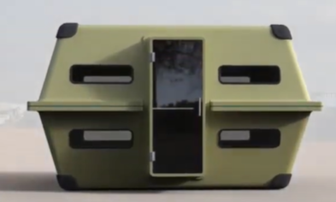

REMOVABLE DOOR

UPPER CAP

LOWER CAP

MODULAR RAPID DEPLOYABLE SHELTER

DESIGN CONSIDERATIONS

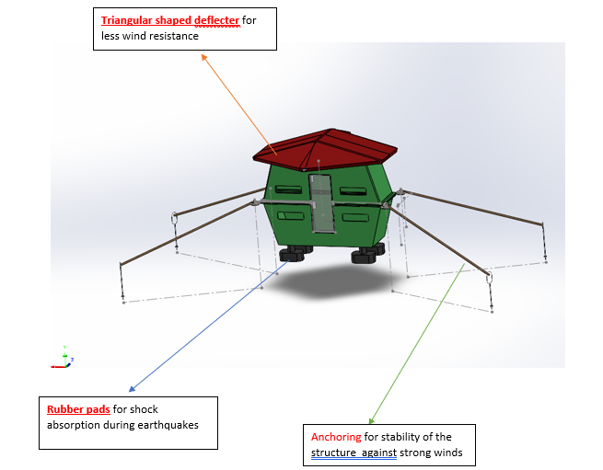

1. Wind resistance

Wind deflectors are fitted to reduce aerodynamic drag .

1. Flood resistance

Anchoring joints are fitted for remaining stable during flood .

1. Modular design

Less number of parts and a simple design allows multiple modules to combine and can be stacked after disassembly .

1. Easy transport

A stackable design allows for easy transport .

1. Cost Efficient

Easily replaceable parts present which reduce long-term costs.

Material Selection

1. Outer Shell

Aluminum Composite Panels (ACP) : **ACP**: Strong, lightweight, and weather-resistant. Used in modern architecture .

1. Structural Frame (Load-Bearing Parts)

Aluminum Alloy: It is lightweight, corrosion-resistant, and easily fabricated .

1. Thermal Insulation

Expanded Polystyrene (EPS): Cost-effective and provides thermal insulation.

1. Shock Absorbers

Neoprene Rubber Pads

STRUCTURAL ANALYSIS

Material Strength & Structural Integrity

Frame (Aluminum Alloy )

* 1. It has high strength-to-weight ratio.
  2. It resists bending and buckling under heavy loads due to flood wind etc.

Wall Panels ( ACP):

* 1. It provides resistance against sudden impacts .
  2. It does not decrease rigidity and at the same time it gives less weight.

ASSEMBLY

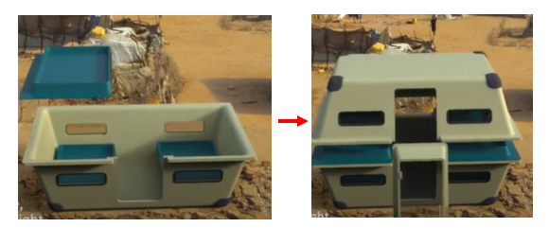

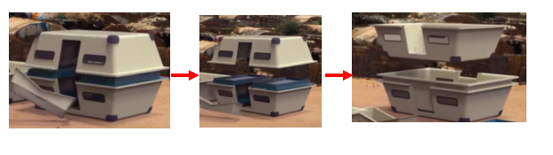DISASSEMBLY

Upper and lower part are stacked together

Door is removed

Upper part is removed

ADVANTAGES

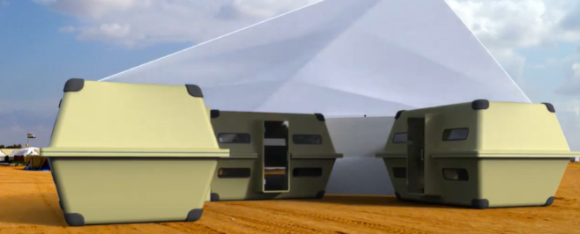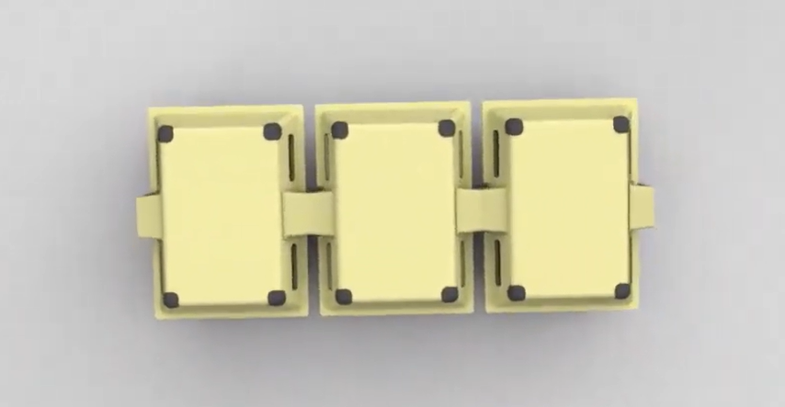

*Can be used for extended families by combining modules together .*

*Can be combined in a row as a medical facility*

*THANK YOU*